Test OFI Import – cartonization

Test Date: 2016.12.14

1. **Import SO – cartonization:**

|  |  |  |  |  |  |
| --- | --- | --- | --- | --- | --- |
| BU | GROUP BY | Order by | importno | Test Date | Test result |
| CTM | SO, Lineitem, FGMaterialNo | SO, Lineitem, FGMaterialNo, Location |  |  |  |
| REBAG | SO, Lineitem | SO, Lineitem, Location |  |  |  |
| SUBCON | SO, Lineitem | SO, Lineitem, Location | 1859 | 14-12-2016 | ok |
| WAFER | SO, Lineitem | SO, Lineitem, AddDate |  |  |  |

-- TEST Import OFI

select SO, lineitem, BoxID , Seqno , Location , LotID, * from SCH_OFI_OUTBOUND_SO_LOT

where ImportNo >= '0000001859'

order by 1, 2 , 3,4

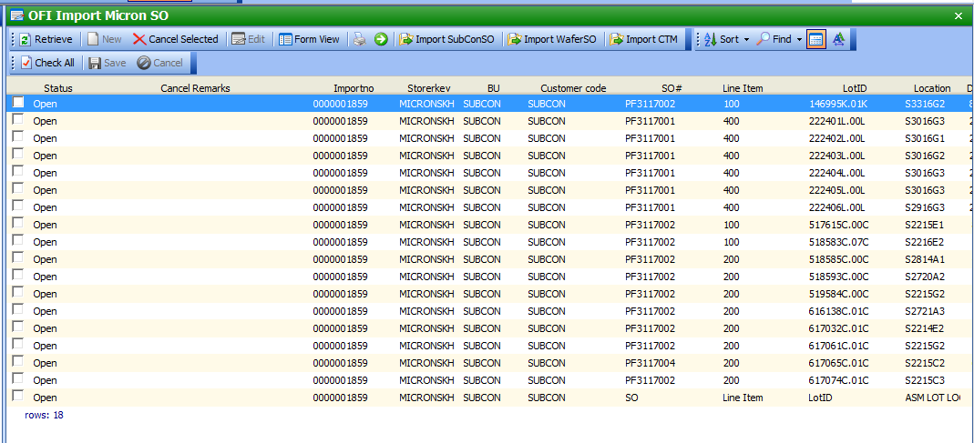

1. Pick list by Box ID
2. Scan by BoxID

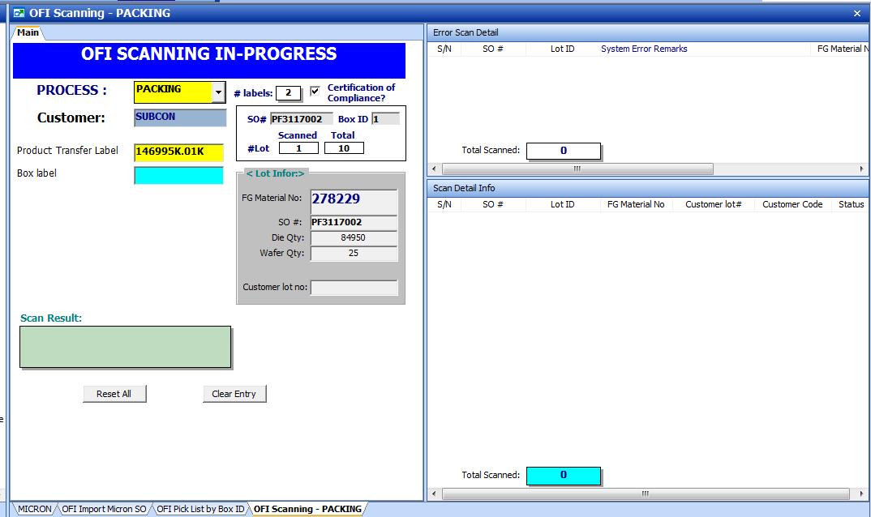

Scan by BOX ID and Seqno in reverse order.

|  |  |  |  |  |  |  |
| --- | --- | --- | --- | --- | --- | --- |
| **SO** | **Line Item** | **BOX ID** | Seqno | **LotID** | **Loc** | **Scanning order of lot#** |
| PF3117001 | 400 | 1 | 1 | 222406L.00L | S2916G3 | 3 |
|  |  | 1 | 2 | 222402L.00L | S3016G1 | 2 |
|  |  | 1 | 3 | 222403L.00L | S3016G2 | 1 |
|  |  | 2 | 1 | 222404L.00L | S3016G3 | 6 |
|  |  | 2 | 2 | 222405L.00L | S3016G3 | 5 |
|  |  | 2 | 3 | 222401L.00L | S3016G3 | 4 |

1. Scan in wrong seq no, system will prompt error and Lot id will be locked. Waiting supervisor to release lock.

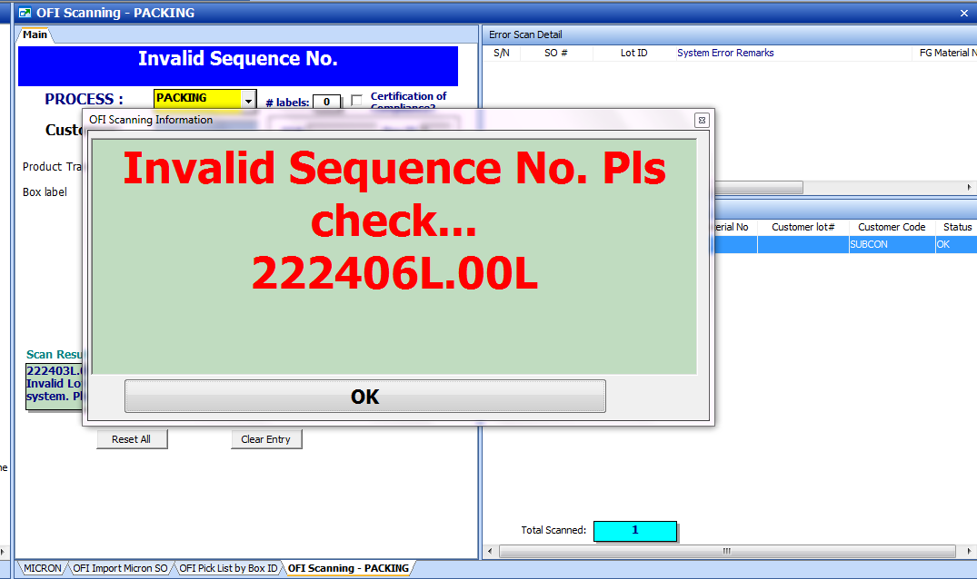

1. Validation:
   1. Invalid Sequence no – system will log error scan, which require Supervisor to Release error.

